Vegetable Gardening 1
Participant Guide

Community and home food gardening are active and affordable ways to improve food security status and be an ecological steward. Vegetables and fruits can be grown in containers, raised beds, or directly into the ground. CCE staff and volunteers are often well-positioned to promote knowledge and skills gains related to growing food in these settings. It is a priority of CCE to work with vulnerable populations to educate families and influence policies that will allow youth, families, and communities to make sound nutritional decisions with constrained resources. (Adapted from the CCE Statewide Plan of Work)

By actively participating in Vegetable Gardening 1, you will:
- Recognize common vegetable families.
- Identify common garden pests and diseases.
- Examine methods to start vegetable seeds indoors and outdoors.
- Describe best management practices for water, weed, pest prevention, and nutrient management for maintaining vegetable and herb crops.

Before Session
READ:
- Excerpt Chapters from Seed to Supper course book (26 pages provided).
- Factsheet Indoor Vegetable Seed Starting (2 pages provided).
WATCH:
  - WATCH
  - Vegetable Gardening Basics, Part One, Steve Reiners https://youtu.be/yvpB0b_76Kk
- Vegetable Gardening Basics, Part Two, Steve Reiners
https://youtu.be/Rz7r5gt54dk
- Ten Things to Know PowerPoint, with Barb Neal
https://youtu.be/NIuYGjLAn-U
DO:
- Any seed packets at home? Bring them to the session. Empty ones are fine.
EXPLORE:
- Take about 20 minutes to explore the Cornell Food Gardening Resources - This is an excellent site as it provides advice on growing 58 different vegetables as well as many herbs. All of it is written for New York growing conditions. It also provides more detailed information on saving seeds, container gardening and variety recommendations. This is a site you will want to keep bookmarked on your computer. You might click on a few links that catch your interest and read a little more or watch a couple videos. https://gardening.cals.cornell.edu/garden-guidance/foodgarden/ and http://www.gardening.cornell.edu/homegardening/scene0391.html

Opening and Introduction
- Facilitator reviews housekeeping, ground rules, learning objectives, and class flow.
Seed Packet Activity
- Facilitator leads participants through small group activity and discussion.
Vegetable Gardening Pests Lecture
- Listen to presentation.
Conclusions
- Facilitator leads group reflection on key take home points and any lingering questions.
Knowledge Check
- Assess what you now know. Be motived and empowered to share with your peers and learn more.
Program Feedback
- Share your insight to help us improve the program, report results, & plan for the future.
After Session

REFLECT:
- What happened?
- What was my response to what happen? How do I make sense of it?
- How does it relate to other things I know?
- What can I conclude?
- What might I do differently next time?

LEARN MORE:
There are a large number of resources about vegetable gardening at Cornell University and beyond, here are a few. This is arranged by NYS Seed to Supper Course Book chapter topics:

Chapter 1- Planning Your Garden
There are a large number of resources about vegetable gardening at Cornell University and beyond, here are a few. This is arranged by NYS Seed to Supper Course Book chapter topics:
Chapter 1- Planning Your Garden
- Vegetable Varieties for Gardeners: http://vegvariety.cce.cornell.edu/main/login.php
- Rain Barrels, Fact Sheet 218; Cornell Cooperative Extension Rockland County: http://rocklandcce.org/resources/rain-barrels
- Plant Rotation in the Garden Based on Plant Families: https://extension.psu.edu/plant-rotation-in-the-garden-based-on-plant-families
- Vegetable Resources, New York State Integrated Pest Management website, Cornell, CALS: https://nysipm.cornell.edu/agriculture/vegetables/resources/
- Troubleshooting, Cornell Garden- Based Learning: http://gardening.cals.cornell.edu/garden-guidance/troubleshooting/
- Late Blight Information; New York State Integrated Pest Management website, Cornell, CALS: https://nysipm.cornell.edu/agriculture/vegetables/pest-alerts-vegetables/late- blight/
- Cornell University Insect Diagnostic Laboratory: http://idl.entomology.cornell.edu
- Pests, Cornell Vegetable Program, CALS: https://cvp.cce.cornell.edu/pests.php#topbo
- Weed Control for the Home Vegetable Garden, Bellinder, Robin R.; Kline, Roger A. and Warholic, Donald T. Cornell University Cooperative Extension: https://ecommons.cornell.edu/handle/1813/3618
- Cornell Publications Wildlife Damage Management Fact Sheets: http://wildlifecontrol.info/publications/cornell-publications
- Cornell Garden-Based Learning Citizen Science projects related to growing vegetables: https://gardening.cals.cornell.edu/adult-programs/citizen-science/
- Vegetable Growing Guides: http://www.gardening.cornell.edu/homegardening/scene0391.html
- Fact Sheets on Food Gardening resource page: https://gardening.cals.cornell.edu/garden-guidance/foodgarden/
Chapter 2- Getting Started with Healthy Soil
- Cover crop guide for New York Vegetable Growers: http://covercrop.org
- Cover Crops for Urban Gardens (Garden Ecology project):
https://blogs.cornell.edu/gep/gardeners
- Healthy Soils, Healthy Communities: http://blogs.cornell.edu/healthysoils
- Soil Contaminants and Best Practices for Healthy Gardens, Cornell Waste Management Institute: http://cwmi.css.cornell.edu/soilquality.htm#research
- Fact Sheets on soil testing resource page http://gardening.cals.cornell.edu/garden-guidance/healthysoil/
Chapter 3- Planting Your Garden
- Fact Sheets on Food Gardening resource page http://gardening.cals.cornell.edu/garden-guidance/foodgarden/
- Vegetable Gardening for Dummies by Charlie Nardozzi, 2009
- How to Grow More Vegetables by John Jeavons, 2012 8th edition
- The Vegetable Gardener’s Bible by Edward C. Smith, 2009
Chapter 4- Caring for Your Growing Garden
Chapter 5 - Harvesting and Using Your Bounty
- Resources in GBL Learning Library Advance Topic Seed Saving
- The National Center for Home Food Preservation; The University of Georgia;
https://nchfp.uga.edu/
- So Easy to Preserve, The University of Georgia, https://setp.uga.edu
- Handy Reference for Drying Vegetables and Herbs; Prepared by Katherine T.
Humphrey and Judy L. Price, Cornell Cooperative Extension Home Food Preservation Experts, 2002; Factsheet Drying Vegetables and Herbs
- Handy Reference for Canning Fruits. Ruth Klippstein, Division of Nutritional Sciences, Cornell University. Factsheet Canning Fruit
- Handy Reference for Canning Vegetables; Ruth Klippstein, Division of Nutritional Sciences, Cornell University. Factsheet Canning Vegetables
- Freezing Fruits and Vegetables; Mary Lou Tenney, Division of Nutritional Sciences, Cornell University. Factsheet Freezing Fruits and Vegetables
- Storage Guidelines for Fruits and Vegetables, Cornell Cooperative Extension of Chemung County; Factsheet Storing Guidelines for Fruits and Vegetables

Campus Links:
- Cornell Garden-Based Learning Food Gardening web page: https://gardening.cals.cornell.edu/garden-guidance/foodgarden/
- Cornell Garden-Based Learning Citizen Science projects related to growing vegetables
https://gardening.cals.cornell.edu/adult-programs/citizen-science/
- Cornell Commercial Vegetables: https://www.vegetables.cornell.edu/

Looking for Cornell people and resources? Don’t Google; try the Cornell web search: http://www.cornell.edu/search/index.cfm

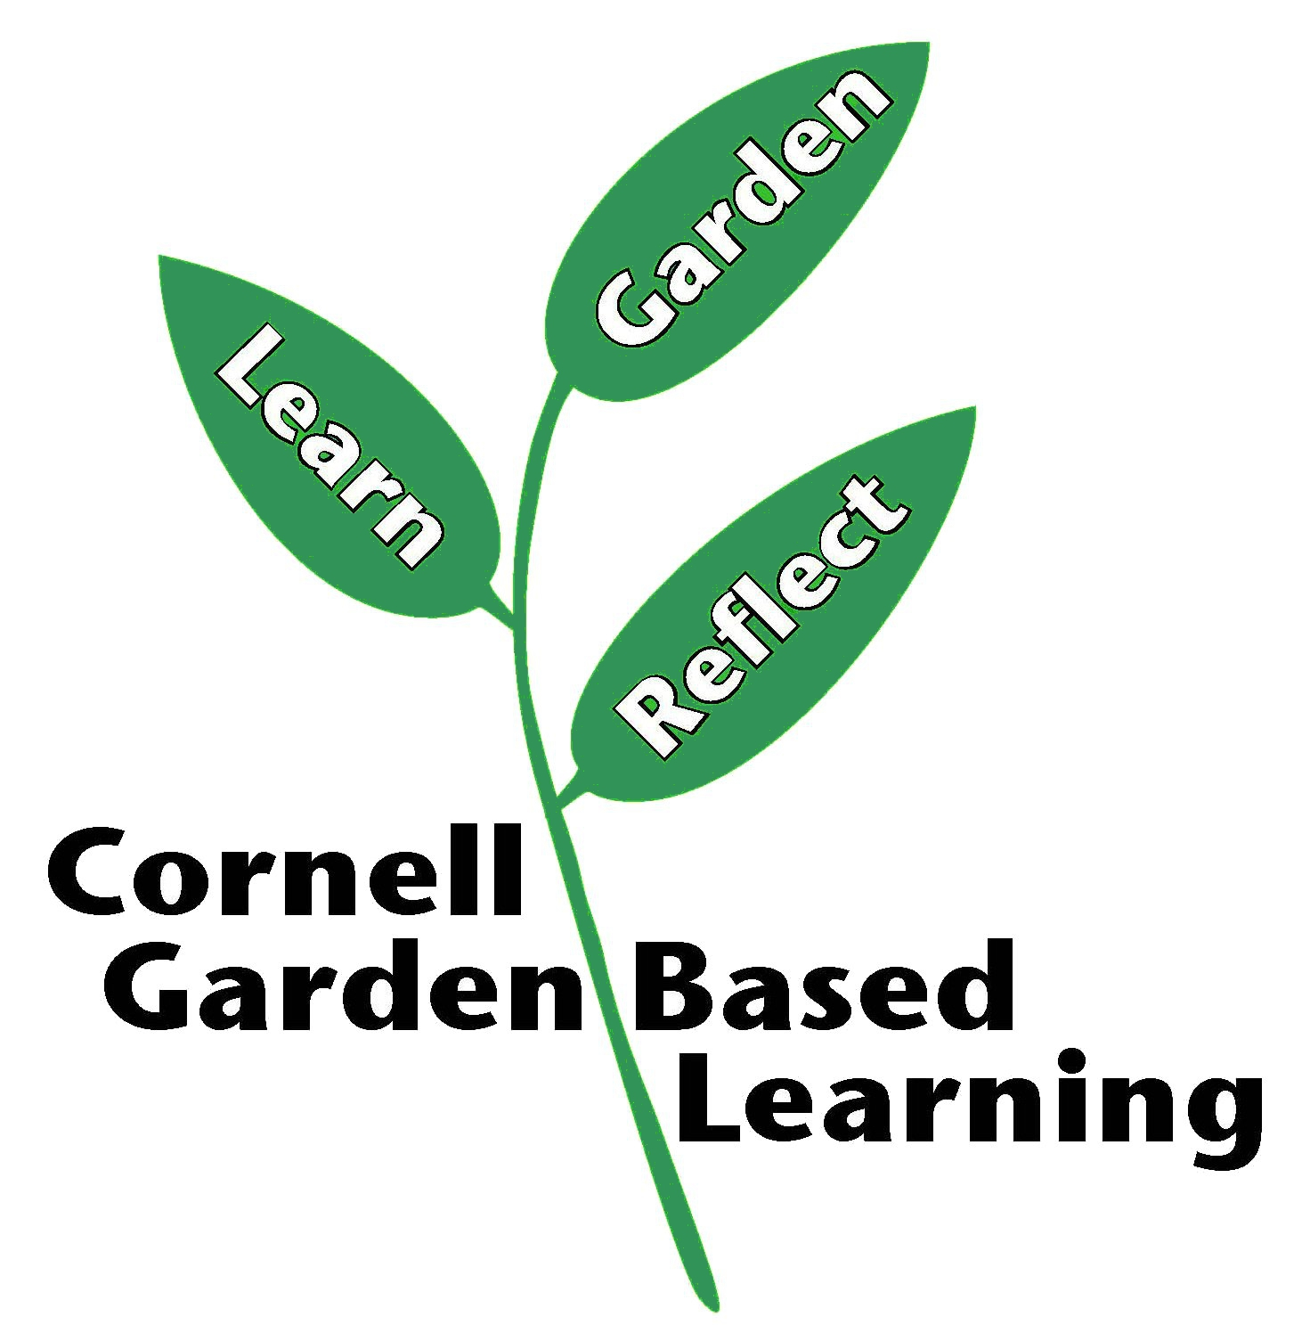
Revised: December 2022, October 2024

