Vegetable Gardening Part 2
Participant Guide
Community and home food gardening are active and affordable ways to improve food security status and be an ecological steward. Vegetables and fruits can be grown in containers, raised beds, or directly into the ground. CCE staff and volunteers are often well-positioned to promote knowledge and skills gains related to growing food in these settings. It is a priority of CCE to work with vulnerable populations to educate families and influence policies that will allow youth, families and communities to make sound nutritional decisions with constrained resources. (Adapted from the CCE Statewide Plan of Work)
By actively participating in Vegetable Gardening 2, you will:
- Create a multi-year plan for a vegetable and herb garden including site selection and preparation, variety selection, season extension, container gardening, and intensive gardening methods.
- Practice answering vegetable garden-related questions.
- Become familiar with how and when to harvest and properly store vegetable and herb crops.
Before Saturday 10/31
READ:
- Excerpt Chapter 1 from Seed to Supper course book (18 pages provided).
- Guide from University of Minnesota Extension on harvesting and storing home garden vegetables: https://extension.umn.edu/planting-and-growing-guides/harvesting-and-storing-home-garden-vegetables
WATCH:
- Advanced Vegetable Gardening, Steve Reiners, narrated by Barb Neal https://youtu.be/T6pJQzIUb1o
- YouTube video series UW-Extension Master Gardener Program:
Vegetable playlist has several mostly short videos; collectively about 60 minutes. https://youtube.com/playlist?list=PLrktjgTJbkvV8eyIUxIL2R8yXjTzwsdkn
DO:
- The Ten Most Asked Vegetable Gardening Questions Worksheet (pdf). Write brief answers and we'll go over this at the beginning of our 11/4 zoom class.
- Vegetable Gardening Part Two Knowledge Check
LEARN MORE:
See list in Participant Guide Vegetable Gardening (Part 1 of 2)

Looking for Cornell people and resources? Don’t Google; try the Cornell web search: http://www.cornell.edu/search/index.cfm

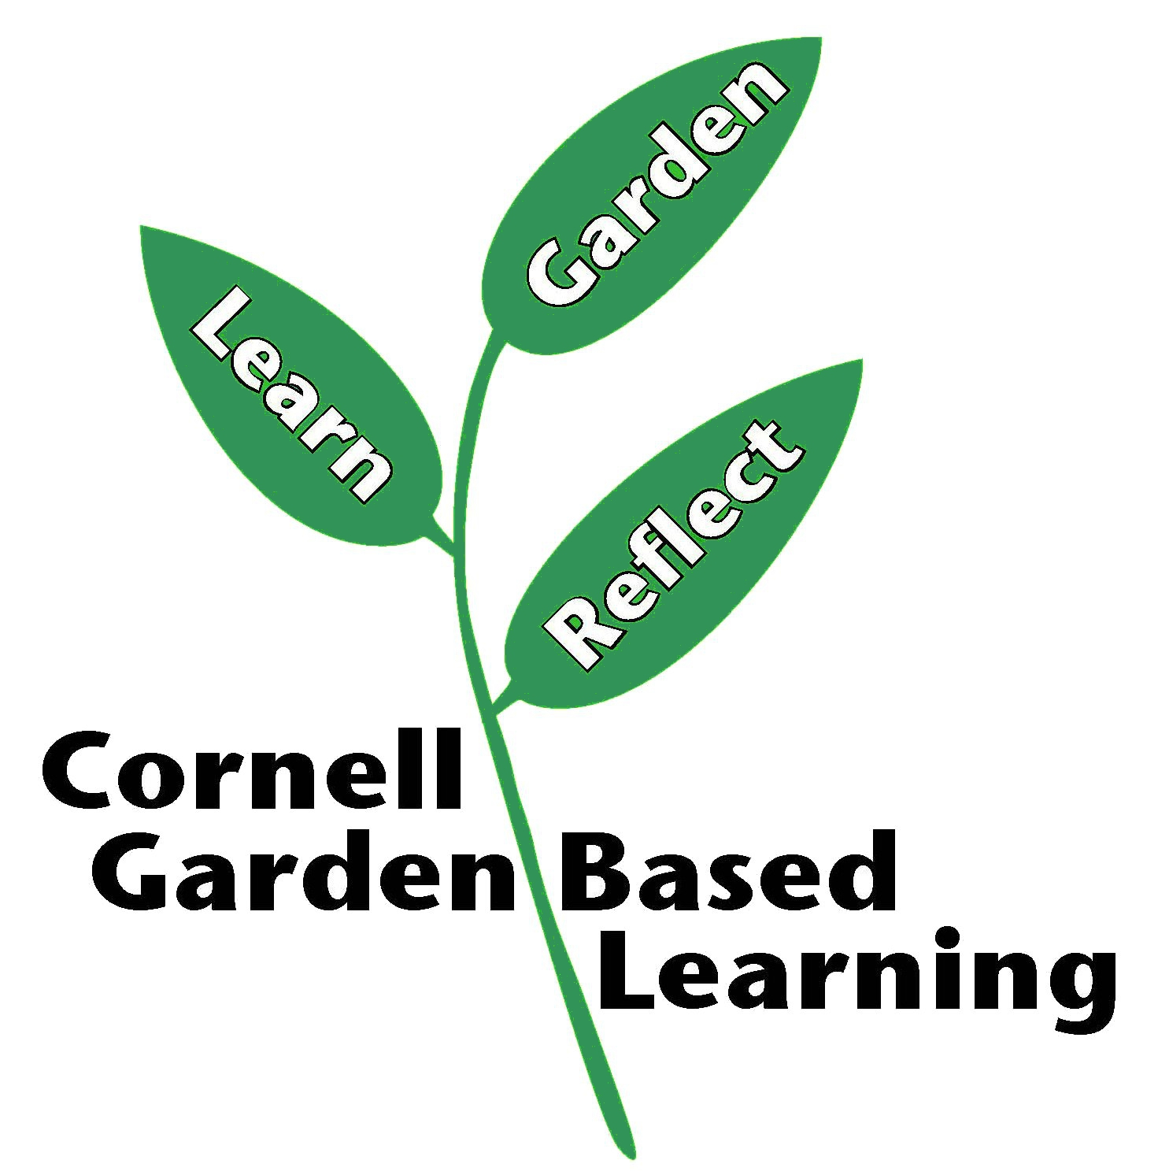
Published: April 2019
Updated: February 2023, August 2024

