Site Assessment Activity


60 minutes

Learning Objective(s): Participants will…
- Apply basic site assessment criteria to a familiar landscape.

Supplies:
Handouts:  - Monocots and Dicots graphic | 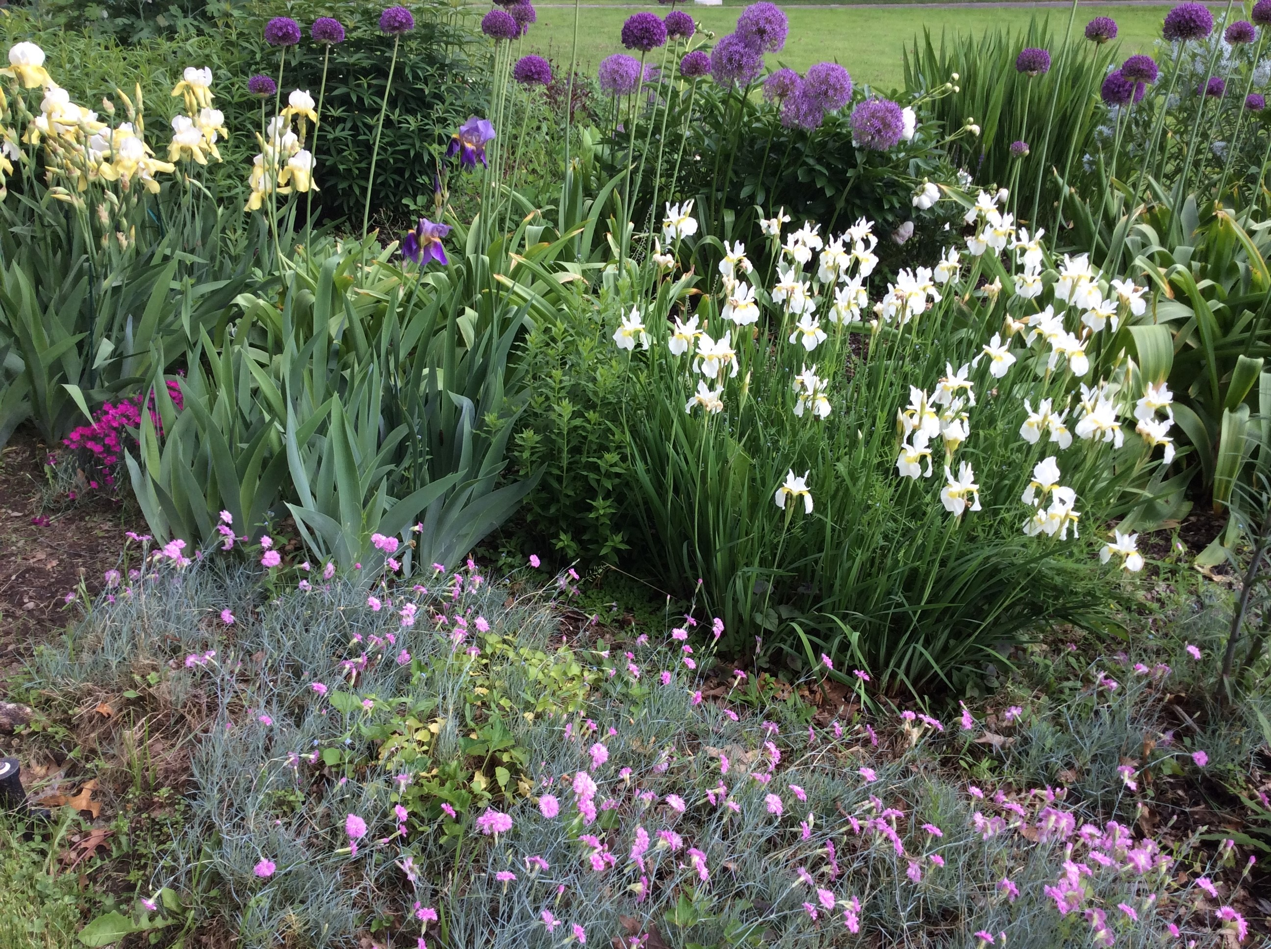
Materials:
- Paper, pencil and clipboard.
- Optional: Camera

Instructions:
Using your property or another familiar landscape such as a nearby park, walk through the site assessment checklist to learn more about the site. Make notes, draw a basic sketch or take photos to represent each bullet.


Date Published: April 2019
Author(s)/Contributor(s): Chrys Gardener, CCE Tompkins Community Horticulture Educator
Reviewer(s): Fiona Doherty

Site Assessment Checklist
Name of Property: I cheated and did my Mom's back porch while I'm here visiting her in NC. She's looking for plants for her patio pots. She lives in a retirement community, so she can't plant into the ground, but my soil sample is from the area around the patio, so I can pretend she can.
- USDA Hardiness Zone: 8a | - Aspect, Include North Arrow
Last Spring Frost: Early March  Last Fall Frost: Early Nov | North  South  East  West
- Sunlight | - Slopes
Full sun (6 hours or more)  Partial sun  Shade | Steep  Moderate  Gradual or flat
- Microclimate factors: | Soil texture (anything we want in pots!) but soil is:
Reflected heat from concrete patio  Frost pocket | Clayey  Loamy  Sandy  Silty
- Wind: | - Soil compaction (if we were planting into it)
Windy site  Windy in isolated sections  Calm site | Compacted  Partially compacted  No compaction
- Obstructions | - Soil drainage characteristics
Below ground centipede grass would call for strong delineation of plantable area.  Above ground There is a balcony above | Wet  Well-drained  Dry
- Wildlife interference
Serious and obvious concerns
Marginal concerns
Not a problem fence around entire community

- Unusual conditions: | - Soil pH: unknown  - Existing Plants: in the surrounding area are long-leaf pines, holly, azaleas and Japanese maple.
Notes: Because of the sunny, sheltered location, my mom could plant even out of her 8a zone, such as a lemon or fig tree, hibiscus, pots of herbs, and other things that might not survive prolonged freezing temps, as it doesn’t often drop below freezing here, and she can always bring them in. I recommended ivy or clematis in pots as well. If she were planting into the soil, she has a lot of options, as she has loamy soil, but she may need to amend it with compost or fertilizer, as the pH and mineral content are unknown. She would need dense plantings that would complete well with centipede grass, things that do well in draining soil, and can handle high heat, as the temps get over 100 degrees in the unsheltered sun here.

