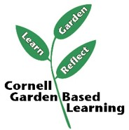
Concept Map
Your Program Title & Objectives
Participants will ….

Pre-requisite skills (in any):
Participants should have a basic understanding of …..

ce.

Topic 4
Topic 5
Topic 3
Topic 2

Target Objectives

Participants will

Target Objectives

Participants will

Target Objectives

Participants will

Target Objectives

Participants will

Learning Activities

Learning Activities

Learning Activities

Learning Activities

Author: Donna Alese Cooke, 2024

