Checklist For a Sustainable Garden Site
Does your garden have:
- Well-drained soil, free of heavy metals such as lead
- Full sun and protection from wind
- Proximity to a water source
- Nearness to classrooms or meeting place with seating and shade
- Storage space for tools and equipment
- Availability of additional space for composting, pathways, improvements, expansion
- Security from theft and vandalism (do people who could watch over the site live nearby?)
- Anything else?

Other things to consider:
- Are there on-site materials that need to be removed, such as blacktop or debris?
- Should you perform a soil test before planning? If so, contact your local Cooperative Extension Office.
- Will you build raised garden beds or plant directly into the ground?
- Is the site location safe for participants? (Will motion-sensor lights be needed, and can they be installed?)
- Will you need a fence to prevent unwanted wildlife from entering?
- Is there a “garden guardian” who lives nearby who can watch over the site to help prevent theft or vandalism?
- Will you have a garden sign (or numerous signs) to educate visitors when no one is available to answer questions?
- How can you ensure the site is accessible to all?
- Are there public restrooms nearby?
- Is the site easy to get to? Accessible by public transportation? Is parking available? Does it have a bike rack?
- Have you communicated with the groundskeeper of the site?
- For school gardens, are there any requirements and/or restrictions by the principal, school district, etc.?
- For community gardens, any ordinances or local restrictions/requirements by local municipality?
Notes:

Revised December 2024
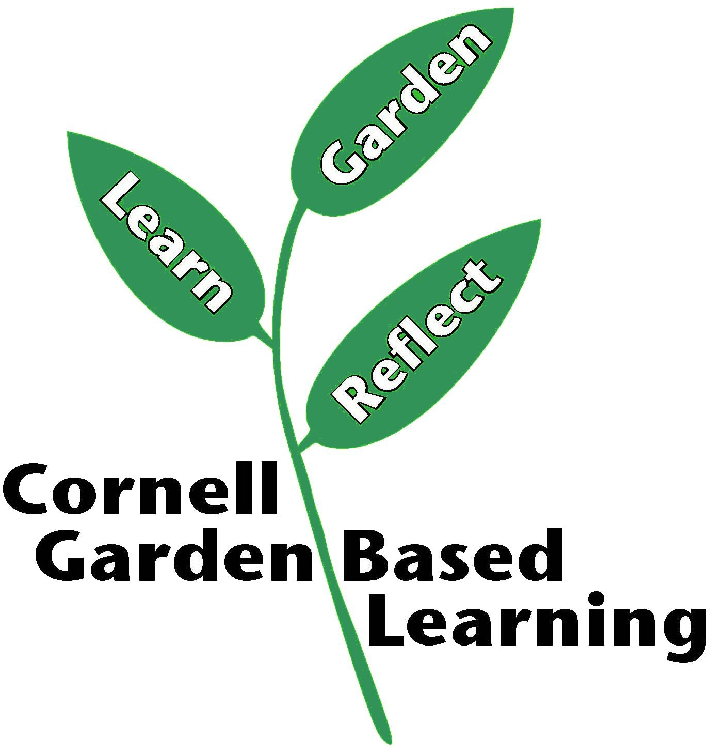
Donna Alese Cooke

