Children, Youth, School, & Community Garden

Logic Model

Often in our programs, we focus on activities, at the expense of looking at a program as a whole. Use this work sheet over time to think of the entire program picture, from your mission, vision, need and unique situation, all the way to what you hope to accomplish with all of your good work. Seen in this way, the “activities” are a path from mission to outcomes — just one part of the program story!
Developed by Marcia Eames-Sheavly for the Cornell Garden-Based Learning Program.

Need/Issue/Situation
Inputs Activities Outputs Short-term Outcomes
Long-term Outcomes


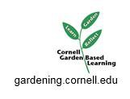
Other...

http://blogs.cornell.edu/garden
Life-long...
Our mission...

Partnerships...
In class, indoors, schoolyard, garden...
Young people engage in or try...
Satisfaction...

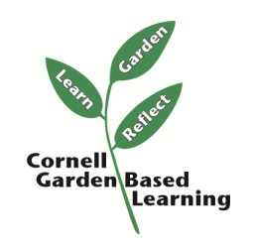
Healthier...
Our community...
Support needed from...
Projects...
Adults model...
Knowledge...
Young people need...
Contributors include...
Field trips...
The community creates...
Participation...
We are concerned about...
Other...
Events...
Increased...
Support for...
Achievement in...

