Planning a Successful School and Community Garden Program
Module 1 Assignment 1.1: Building Community Partnerships

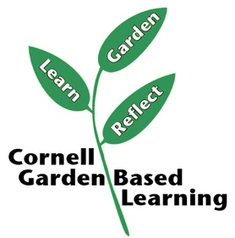
January 2026

