Soils and Fertilizers FAQs
Sourced from Healthy Soils, Healthy Communities, http://blogs.cornell.edu/healthysoils/faqs/
Soil Testing
Q. Should I be concerned about contaminants in my soil?
A. The location and history of your site can provide clues about the quality of your soil. Contamination by heavy metals or other chemicals of concern may be more likely if any of the following are true for your soil:
- Near a house or other structure built prior to the 1980s
- Near high-traffic area
- On old farm or orchard land
- Near factory, manufacturing facility, or other industry
- Near structures made of treated lumber
- Evidence of past burning or chemical spills (e.g., stains, odors)
Learn More: Sources and Impacts of Contaminants in Soils, https://ecommons-new.library.cornell.edu/handle/1813/14282
Q. Should I test my soil?
A. Soil quality – including soil fertility, levels of contaminants, and other properties – is affected by location, past and present land use, and many other factors.
Testing your soil might be a good option if:
- More information about levels of lead and other contaminants might change how you’d use the site. For example, lead contamination may require that you grow everything in containers or well-constructed raised beds.
- You have a specific question that testing can help answer. Examples: Are levels of lead higher next to my house? Where is the best spot for my new garden?
- You can afford the analytical costs for a few soil samples, as well as the costs for clean soil, compost, or other materials as needed.
It might be best to focus on healthy gardening practices rather than testing if:
- You’ve already tested your soil.
- You would rather spend your money on clean soil and compost or other materials instead of testing fees.
- You’re pretty sure that contaminants are a concern, and test results probably won’t change the steps you’d take at your site.
Learn More: Guide to Soil Testing and Interpreting Results, https://ecommons-new.library.cornell.edu/handle/1813/14283
Q. What should I test for?
A. Common soil tests include:
- Soil health and fertility – pH, organic matter, nutrients
- Total elemental analysis for lead, arsenic, and other metals
- Lead screening (different methods used
In most circumstances we do not recommend testing for pesticides or organic contaminants such as PAHs. Testing for these substances is expensive, and results are difficult to interpret.
Learn More: See the Cornell Nutrient Analysis Laboratory and the Cornell Soil Health Testing Laboratory for more information.
Q. How do I collect soil samples?
A. There is no one-size-fits-all strategy. The best sampling plan for your site will depend on your particular situation, and what questions you’d like the test results to help answer. Think about whether you’d like to measure levels of nutrients, metals, or other soil properties across your site, or if you’d like to focus on a particular location.
It is usually best to have results from several samples – not just one. Composite samples are often a good way to get a general sense of the soil characteristics for an area of interest.
See sample collection information in our “Guide to Soil Testing and Interpreting Results”
Q. Where do I send my samples?
A. Different labs use different methods, and costs vary. Labs also provide different interpretation materials – or sometimes none at all!
Some commercial labs and college/university labs test soils for lead and other metals. Some labs test for other soil properties as well.
- A list of labs certified by the NY State Department of Health Environmental Laboratory Approval Program can be found at https://www.wadsworth.org/regulatory/elap/certified-labs. Using a certified lab is important when testing has implications for public health or may be used in legal proceedings.
- The Cornell Nutrient Analysis Laboratory offers Total Elemental Analysis (package 2021 on the Soil Analysis Submission Form), which is often a good choice for gardeners.
- The NYC Urban Soils Institute offers testing through the Environmental Sciences Analytical Center at Brooklyn College for heavy metals, lead screening, and other soil properties (see https://usi.nyc/divisions/soil-testing/)
- The Cornell Soil Health Testing Laboratory offers several packages and add-on services for measuring soil health (see http://soilhealth.cals.cornell.edu/testing-services/comprehensive-soil-health-assessment/).
- Community events (“soilSHOPs“) sometimes offer soil screening for lead and other properties.
Q. What do test results mean, and what should I do?
A. Healthy gardening practices are important, regardless of whether or not you test your soil. These practices have many benefits beyond reducing people’s contact with contaminants. You can find more information on our Healthy Gardening page, which includes information on “What Gardeners Can Do: 10 Best Practices for Healthy Gardening” and other resources.
Compost is a valuable tool for improving soil health and managing contamination. See our Compost page for highlights from the Cornell Waste Management Institute’s compost resources.
If you have tested your soil, comparing results to both soil background concentrations and health-based guidance values can be helpful. For lead in particular, there is no “safe” level, but these comparisons can help you understand more about possible risks so that you can make more informed decisions.
If you’re looking for help understanding test results, try our resources “Metals in Urban Garden Soils” and “Guide to Soil Testing and Interpreting Results“. Our Soil Contaminants page has more information as well.

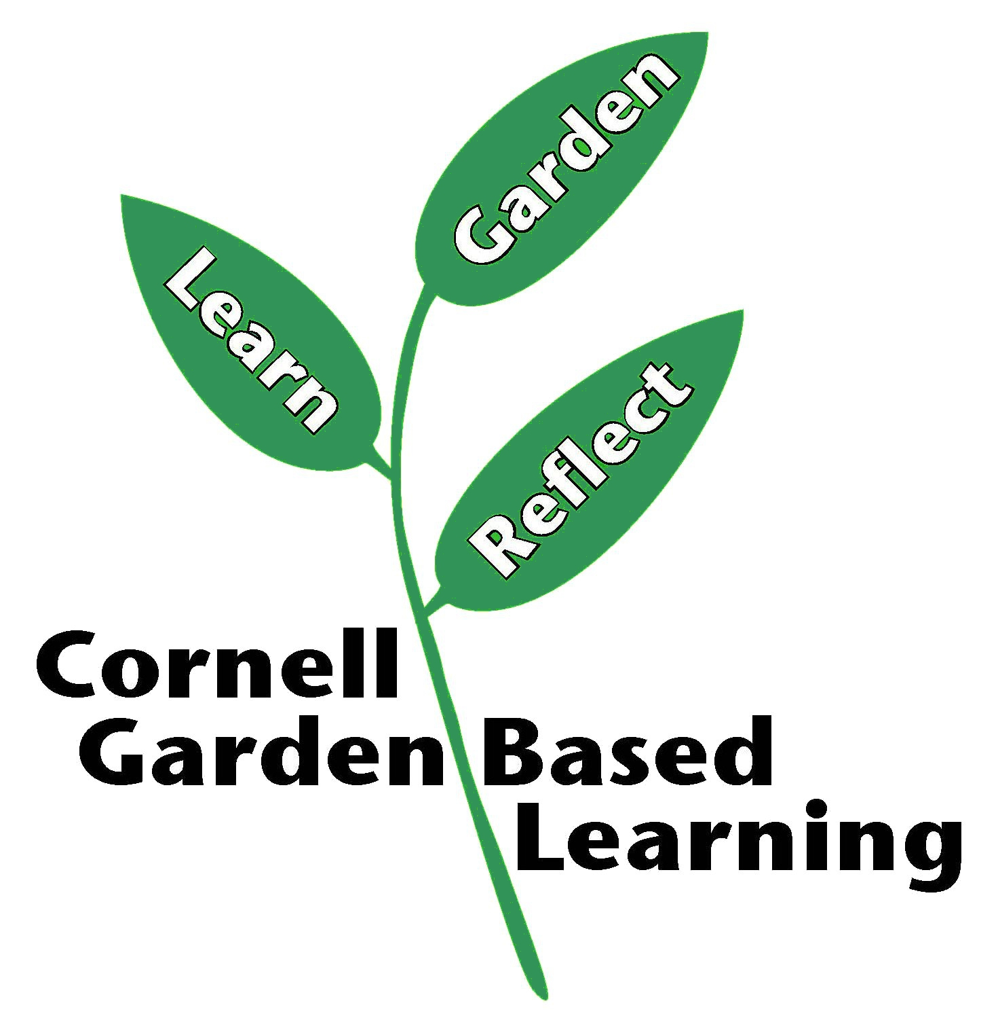
Date Published: April 2019
Contributors(s): Hannah Shayler, Extension Associate
Reviewer(s): Annie Christian-Reuter, Michelle Podolec, Donna Alese Cooke
Please note that neither CCE nor any representative thereof makes any representation of any warranty, express or implied, of any particular result or application of the information provided by us or regarding any product. If a product is involved it is the sole responsibility of the User to read and follow all product labeling instructions and to check with the manufacturer or supplier for the most recent information. Nothing contained in this information should be interpreted as an express or implied endorsement of any particular product or criticism of unnamed products. With respect to any information on pest management the User is responsible for obtaining the most up-to-date pest management information. The information we provide is no substitute for pesticide labeling. The User is solely responsible for reading and following manufacturer’s labeling and instructions. – 2018 F.O.R.M. Code 1501 pg 20

