**WHOLENESS REFLECTION ACTIVITY**

Wellness is an active/participatory process through which people become aware of and make choices toward a more aligned life.

**STEP 1** Review the Eight Dimensions of Wellness

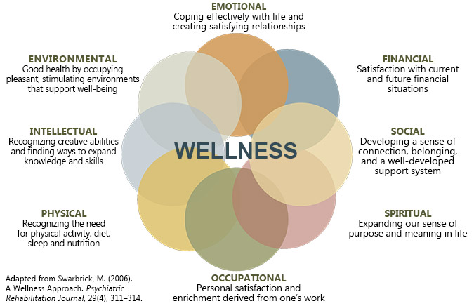

**STEP 2** Assess Your Current Energy Investment

In which dimension are you investing the most/least energy right now? Indicate in the bars below how much time and energy you have positively invested in each of the eight dimensions THIS week.

None Just Enough A Lot

|  |  |
| --- | --- |
| Emotional |  |
| Financial |  |
| Social |  |
| Spiritual |  |
| Occupational |  |
| Physical |  |
| Intellectual |  |
| Environmental |  |

**STEP 3** Create Your Ideal Vision of Wholeness

Imagine you have **only** 40 “energy blocks” to devote across the eight dimensions. Fill in the 40 blocks below to indicate how your ideal self would distribute those blocks across the dimensions. Devote a minimum of 1, and a maximum of 10 energy blocks to each dimension.

1 2 3 4 5 6 7 8 9 10

|  |  |  |  |  |  |  |  |  |  |  |
| --- | --- | --- | --- | --- | --- | --- | --- | --- | --- | --- |
| Emotional |  |  |  |  |  |  |  |  |  |  |
| Financial |  |  |  |  |  |  |  |  |  |  |
| Social |  |  |  |  |  |  |  |  |  |  |
| Spiritual |  |  |  |  |  |  |  |  |  |  |
| Occupational |  |  |  |  |  |  |  |  |  |  |
| Physical |  |  |  |  |  |  |  |  |  |  |
| Intellectual |  |  |  |  |  |  |  |  |  |  |
| Environmental |  |  |  |  |  |  |  |  |  |  |

**STEP 4** Reflect on Your Vision: Reconciliation, Rebalance, Values, Inspiration

Compare your actual energy habits and investments from Step 2 with the ideal vision in Step 3. What do you notice? What would you like to improve upon, feel, or be (if anything)? Accept whatever you notice as a possibility. As you do so, reflect on the different values listed below. Is there any value or group of values you need to identify, align with, celebrate, or re-assert in your life that can be helpful to you right now? Check off up to five values. Can you think of others not on this list? What inspires you?

□ Spirituality □ Transformation □ Social Good □ Challenge □ Boldness □ Stability □ Popularity □ Family □ Legacy □ Beauty □ Fun □ Influence □ Service □ Pleasure □ Security □ Growth □ Success □ Curiosity □ Power □ Friendship □ Religion □ Peace □ Exploration □ Wholeness □ Justice □ Freedom □ Recognition □ Mystery □ Love □ Community □ Achievement □ Reputation □ Creativity □ Intimacy □ Gratitude □ Integrity □ Unity □ Nature □ Wisdom □ Status □ Respect □ Adventure

Adapted from the National Wellness Institute, Inc. © 2017